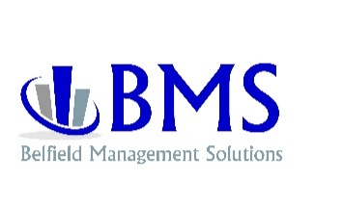

CONSULTING ASSURANCE

As stated in Belfield Management Solutions “Working Agreement for Consulting Services”:

Consulting services rely on many factors, including cooperation of the client staff and professional advisors in providing required information and records, along with the agreement to implement the strategies and recommendations developed during the course of the engagement - all matters over which Belfield Management Solutions has no control.

Belfield Management Solutions will, upon satisfactory completion of the consulting engagement, assure to ____________________________ the realization of a return, through a combination of cost savings, profit enhancements and/or revenue increases, in excess of 2 (two) times the investment incurred for consulting hours billed, during the twelve months following the successful completion of the project.

Early detection of variance in projected profits, and effecting changes designed to bring the identified variance back into compliance, is instrumental in assuring achievement of profitability goals. To this end, it is essential that ___________________________ provide timely Monthly Financial and Operational Summary Reports to the Client Relations Department of Belfield Management Solutions, for review during the one-year period, and such other reports as may be determined during the course of the project.

If an unfavorable variance should develop, a Senior Business Consultant will be assigned to assure your satisfaction (by phone or by personal engagement, at Belfield Management Solutions) without hourly billing charges. Said engagement will be for the specific period of time and with a specific focus, in order to initiate actions that will realize the two (2) to one (1) return on investment.

The return shall be determined by the consistent application of generally accepted accounting principles without changes in methodology, excluding extraordinary and capital expenditures, and leases or contracts negotiated subsequent to the completion of the initial consulting engagement.

___________________________________ ________________________________
Client Belfield Management Solutions

www.belfieldinc.com

